Identifying Key Entities in Recipe Data Report

Business Objective
The goal of this assignment is to train a Named Entity Recognition (NER) model using Conditional Random Fields (CRF) to extract key entities from recipe data. The model will classify words into predefined categories such as ingredients, quantities and units, enabling the creation of a structured database of recipes and ingredients that can be used to power advanced features in recipe management systems, dietary tracking apps, or e-commerce platforms.

Data Description
The given data is in JSON format, representing a structured recipe ingredient list with Named Entity Recognition (NER) labels. Below is a breakdown of the data felds:

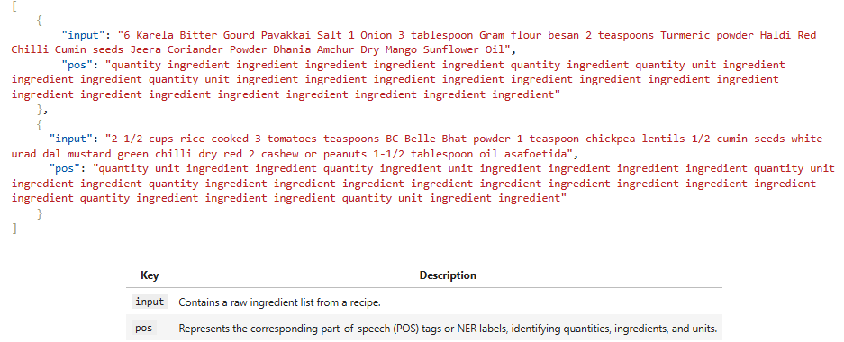

Methodology and Techniques Used
This project follows a structured pipeline to perform Named Entity Recognition (NER) on recipe ingredient data. The methodology involves multiple stages from data preprocessing to model evaluation.

Techniques Applied
Natural Language Processing (NLP): We applied core NLP techniques such as:
- Lexical Analysis: Tokenizing the text into words.
- Syntactic Analysis: Using Part-of-Speech (POS) tagging and dependency parsing.
- Named Entity Recognition (NER): Identifying entities such as quantity, unit, and ingredient.
Machine Learning with CRF: A Conditional Random Field (CRF) model was used for sequence labeling, suitable for tasks like NER where context is important.
Exploratory Data Analysis (EDA): Basic data inspection and visualization helped us understand the dataset structure, token distribution, and label balance.

Library Setup
The following Python libraries were used for various purposes:
- Data Handling: json, pandas, re, collections.Counter, fractions
- NLP Processing: spacy
- Machine Learning & CRF: sklearn_crfsuite, sklearn, joblib
- Visualization: matplotlib.pyplot, seaborn
- Utility & Sampling: random, numpy
The sklearn-crfsuite library plays a central role as it allows training CRF models using scikit-learn-like API, which is well-suited for structured output problems like NER.

Data Loading and Preprocessing
- A custom function was written to load recipe data from a JSON file into a DataFrame.
- The input text and associated POS tags were split into lists of tokens (input_tokens and pos_tokens).
- We validated the integrity of the data by comparing the lengths of input and POS sequences using newly created columns (input_length and pos_length).
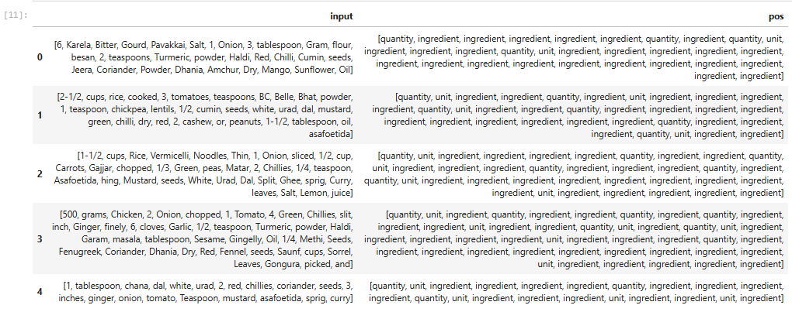
Data Cleaning and Validation
To ensure clean and consistent data for training, the following steps were performed:
- A custom unique_labels function was created to extract all unique POS tags used in the dataset. The main labels identified were 'quantity', 'unit', and 'ingredient'.
- We validated that each input sequence had a matching number of POS tags. Any rows where the lengths did not match (e.g., index 17, 27, 79, 164, 207) were considered invalid.
- These mismatched rows were removed to maintain alignment between the tokens and their labels.
- Finally, the input_length and pos_length columns were recalculated to reflect the cleaned dataset.
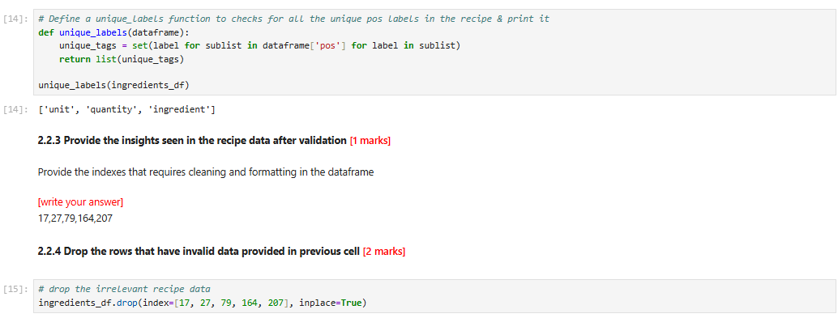

Train-Validation Split
To evaluate the model effectively, the dataset was divided into training (70%) and validation (30%) sets using the train_test_split method with a fixed random_state of 42 for reproducibility.
- The input_tokens and pos_tokens were split into X_train, X_val and y_train, y_val respectively.
- All outputs were converted into NumPy arrays for faster processing and compatibility with the CRF model.

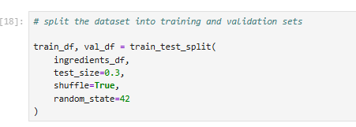

Exploratory Data Analysis on Training Data
Basic exploratory analysis was done on the training data to understand common ingredients and units used in the recipes:
Top Frequent Ingredients:
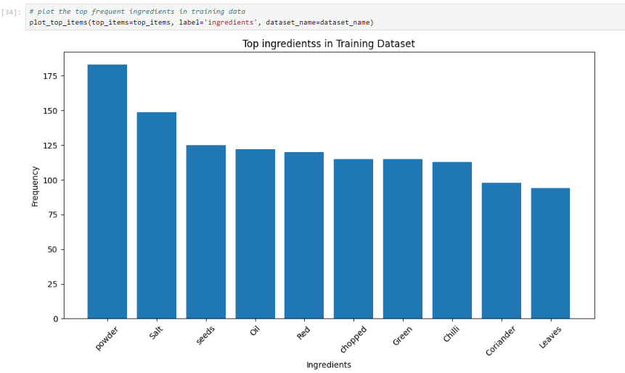
Top 5 Ingredients:
1. powder (183 occurrences)
2. Salt (149 occurrences)
3. seeds (125 occurrences)
4. Oil (122 occurrences)
5. Red (120 occurrences)
These results show that spices, seasonings, and common cooking ingredients dominate the dataset, reflecting typical Indian cuisine patterns.

Top Frequent Units:
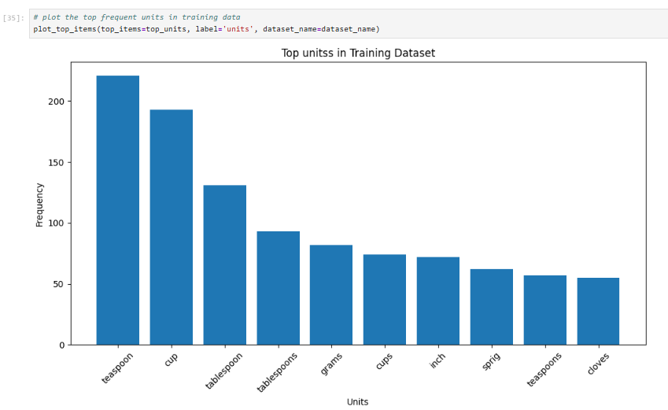
Top 5 Units:
1. teaspoon (221 occurrences)
2. cup (193 occurrences)
3. tablespoon (131 occurrences)
4. tablespoons (93 occurrences)
5. grams (82 occurrences)
The data shows that volume measurements (teaspoon, cup, tablespoon) are most common, followed by weight measurements (grams) and specialized units (inch, sprig, cloves).

Feature Engineering and Weighting
To improve model performance and reduce class imbalance, the following steps were applied:
- The training label data (y_train) was flattened to create a single list of labels (y_train_fat). This allowed us to count the occurrence of each label and compute label_counts.
- Using these counts, class weights were calculated through the inverse frequency method. This gives more importance to less frequent labels like quantity and unit.
- To address the heavy dominance of the ingredient label, its weight was deliberately penalized to avoid model bias.
- A custom function extract_features_with_class_weights was defined to include these weights while generating features for both training and validation data.

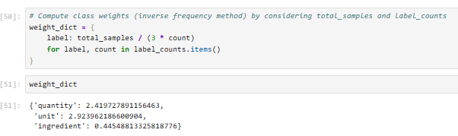

Model Building and Training
A Conditional Random Fields (CRF) model was implemented using the sklearn_crfsuite library.
CRFs are particularly suitable for sequence labeling tasks like Named Entity Recognition (NER) because they take into account dependencies between neighboring labels, improving context-aware predictions.
The model was trained on the cleaned and feature-enhanced dataset using class weights to reduce the impact of label imbalance. The 'ingredient' label, being highly frequent, was penalized to ensure fair learning across all entity types.

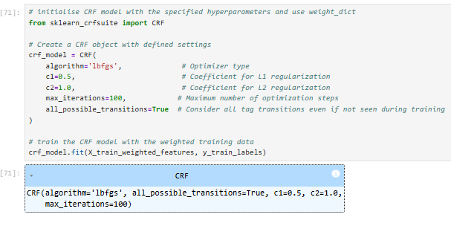

Model Evaluation
The model’s performance was assessed using:
- Precision, Recall, and F1-Score for each class
- Confusion Matrix for visualizing classification accuracy and errors
- Overall Accuracy on both training and validation datasets
This evaluation provided a comprehensive view of how well the model learned the data and generalized to unseen examples.

Results and Performance
Training Set Results
- Quantity: Precision 99.59%, Recall 98.88%, F1-Score 99.23%
- Unit: Precision 97.90%, Recall 97.90%, F1-Score 97.90%
- Ingredient: Precision 99.47%, Recall 99.61%, F1-Score 99.54%
- Overall Accuracy: 99.31%
- Total Tokens in Training Set: 7,114
The training confusion matrix showed excellent classification, with very few misclassifications. Most confusion was between similar entity types like unit and ingredient, but errors were minimal.

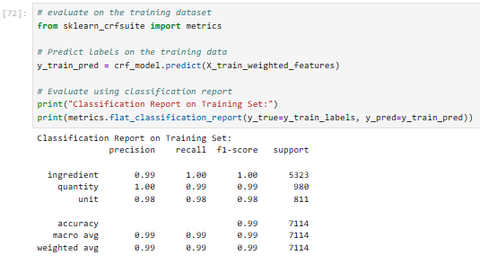
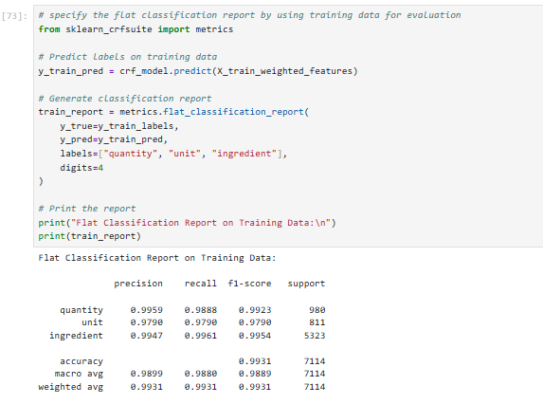
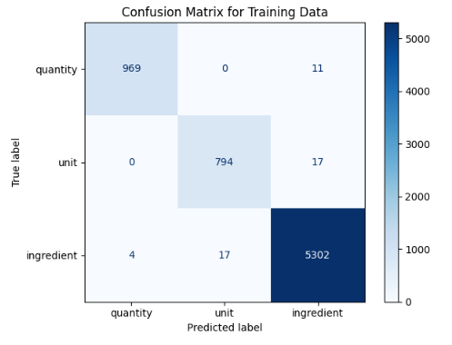

Validation Set Results
- Quantity: Precision 99.02%, Recall 98.05%, F1-Score 98.53%
- Unit: Precision 97.37%, Recall 93.02%, F1-Score 95.14%
- Ingredient: Precision 98.64%, Recall 99.57%, F1-Score 99.10%
- Overall Accuracy: 98.54%
- Total Tokens in Validation Set: 2,876
The validation confusion matrix confirmed strong generalization. Most ingredient tokens were correctly predicted, while some confusion was observed in unit labels, especially in ambiguous measurement contexts.

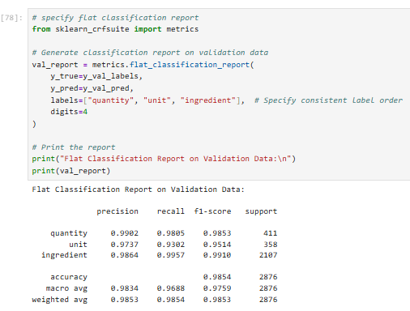

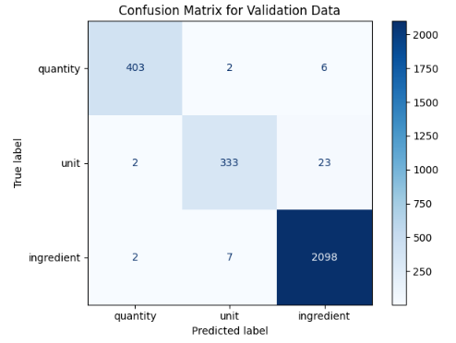

Error Analysis
A total of 42 errors were found in the 2,876 validation tokens, yielding an error rate of 1.46%.
Error Distribution:
- Quantity: Very few errors due to consistent patterns (403/411 correct)
- Unit: Most errors occurred here (26/358 incorrect), often due to ambiguous measurements
- Ingredient: Performed best overall, with only minor misclassifications (2098/2107 correct)
Key Error Patterns:
- Ambiguous tokens serving as both ingredient and unit
- Multi-word ingredient names being split or mislabeled
- Context-dependent measurement terms
- Unseen or novel ingredient names not present in training data.

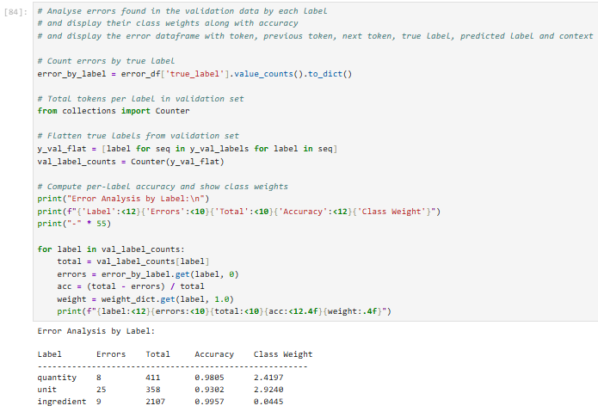

Key Achievements
- Built a high-accuracy NER system for recipe-style text
- Reached 98.54% validation accuracy through robust CRF modeling and balanced training
- Applied effective class weighting to reduce bias toward dominant labels
- Established a clean, reusable pipeline for entity extraction in recipes.

Summary
The CRF model effectively extracted recipe entities with over 98% accuracy, demonstrating strong generalization and minimal error. Through strategic feature engineering and class balancing, the system proved robust for practical NER applications in culinary text.

